1 Are the HTML tags and elements the same thing?

No. The starting and ending point parts of an HTML document are *HTML* *Tags.*

*Eg .* <hr>, <img>, <br>

Elements in HTML enclose the content in between the tags.

Eg. <p> hello</p>

2. What are tags and attributes in HTML?

Attribute:

It always placed in the opening tag of an element.

Eg. <**p** color=”pink”>lorem</**p**>

Tag: The starting and ending point parts of an Html document are *Html Tags.*

*Eg .* <hr>, <img>, <br>

3. What are void elements in HTML? With Example

Void elements do not close with end tag

Eg.<hr>,<img>,<link>,<area>,<br>

4. What are HTML Entities? With Example.

Html entities is specific symbol code .which start with &nd code

It define any symbol like

Eg, **&#169;** currency symbol code ©

5. What are different types of lists in HTML? With Example

There are three type of list in html

1.Unorderlist

Eg.it generate symbol like square,disc,round etc.

* 123
* 123
* 123

2.Orderlist

Eg.it generate list like 123,abc,roman number series etc.

1. 123
2. 123
3. 123

## 3 Description list

Eg. In this list we can use only Describe the data like.

Furniture:

Table ,chair,bed,sofa etc.

6. What is the ‘class’ attribute in HTML? With Example.

class is an attribute that specifies one or more class names for an HTML element.

Eg.

<head>

<Style>

.div1{

Height:300px;

Width:300px;

Background color:pink;

}

.div2{

Height:300px;

Width:300px;

}

</head>

</style>

<Body>

<div class=”div1”>aschshdjhds</div>

<div class=”div2”>aschshdjhds</div>

</body>

7. What is the difference between the ‘id’ attribute and the ‘class’ attribute of HTML elements? With Example.

The only difrence between id nd class is id is given only time while class we use multiple time.

Eg.

<Body>

<div class=”div1” id=”id1” div3>aschshdjhds</div>

<div class=”div2” id=”id2” div3>aschshdjhds</div>

</body>

8. What are the various formatting tags in HTML?

<b> - Bold text

<strong> - Important text

<i> - Italic text

<em> - Emphasized text

<mark> - Marked text

<small> - Smaller text

<del> - Deleted text

<ins> - Inserted text

<sub> - Subscript text

<sup> - Superscript text

<u>-underline

9. How is Cell Padding different from Cell Spacing? With Example

Cell padding is the space between the cell edges and the cell content.

**Cellspacing is specifies the space between cells**

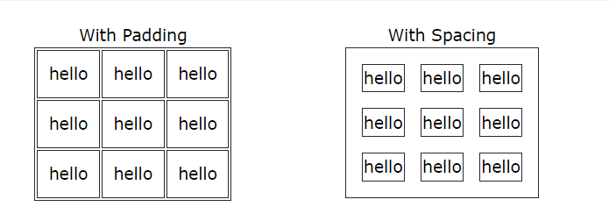

10 How can we club two or more rows or columns into a single row or column in an HTML table? With Example

Using rowspan nd colspan we can merge row nd column.

Eg.

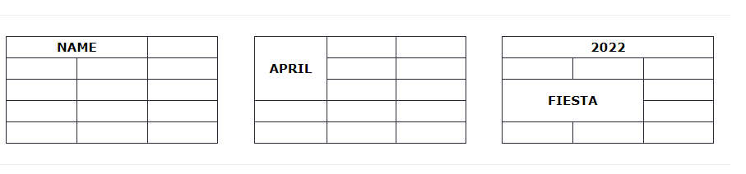

11. What is the difference between a block-level element and an inline element?

A block element always start with new line when we can apply

Eg.<div>

Inline element does not start with new line

Eg.<span>

12 How to create a Hyperlink in HTML? With Example.

Using <a> anchor tag we create hyper link.

<a href=””>Home</a>

13. What is the use of an iframe tag? With Example.

Iframe tag use when we open another new link ,text,image,location,video.

Eg.

<I frame src=””></iframe>

14. What is the use of a span tag? Explain with example?

Span tag is inline element.we use span .we can use span tag in div tag but cant use span tag in div.

Eg. <div>

hello

<span>hello</span>

</div>

15. How to insert a picture into a background image of a web page? With Example.

Using image tag we can add background image of web page

Eg, background imagr:url();

16. How are active links different from normal links?

In active link we can navigate to another page

In normal link we can’t navigate to another page.

17. What are the different tags to separate sections of text?

<Br> using this tag we can get text in new line.

<hr> using this tag we can seprate section of text.

18. What is SVG?

Svg Is semi vector graphic.we can draw rectangle ,circle.

19. What is difference between HTML and XHTML?

XHTML stands for extensible **m**yper **t**ext **m**arkup **L**anguage.

Html stand for hyper text markup language.xhtml Upgraded version of html.

20. What are logical and physical tags in HTML?

Physical tags are used specific characters are to be formatted using HTML tags.

Eg. <sub>,<sup>,<b><u>

Logical tag they specify the structure of the document.

Eg <abbr>,<strong>.

Code:

<!DOCTYPE html>

<html lang="en">

<head>

    <meta charset="UTF-8">

    <meta name="viewport" content="width=device-width, initial-scale=1.0">

    <title>Document</title>

</head>

<body>

    <table border="1" width="100%">

        <tr>

            <td rowspan="2"><a href="">Home</a></td>

            <td rowspan="2"><a href="">About</a></td>

            <td rowspan="2"><a href="">Contact</a></td>

            <td rowspan="2"><a href="">Help</a></td>

            <td rowspan="2"><a href="">store</a></td>

            <td  rowspan="1" style="background-color: red;"><a href="">Detailled</a></td>

        </tr>

        <tr>

            <td style="background-color: red;"><a href="">apps</a></td>

        </tr>

        <table border="1" width="100%">

        <tr>

            <td><img src="iamge/1.jpg""  height="350px" width="1500px"></td>

        </tr>

        </table>

        <table border="1" width="100%">

        <tr>

            <td style="text-align: center;background-color: palevioletred;">Contact Us Page</td>

        </tr>

        <tr><td><img src="iamge/1.jpg""  height="350px" width="1510px"></td></tr>

        </table>

        <table border="1" width="100%" cellpadding=""5px" style="background-color: skyblue; text-align: center;">

        <tr>

                <td><label for="">First Name:</label>

                <input type="text" placeholder="Enter Your name"></td>

                <td><label for="">Last Name:</label>

                    <input type="text" placeholder="Enter Your name"></td>

            </tr>

            <tr>

                <td><label for="">Email:</label>

                    <input type="text" placeholder="Enter Your email"></td>

                <td><label for="">phone No:</label>

                    <input type="text" placeholder="Enter Your Phone no"></td>

            </tr>

            <tr>

                <td><label for="">City</label>

                <select>

                    <option value="">---Select city---</option>

                    <option value="">Ahmedabad</option>

                    <option value="">Baroda</option>

                    <option value="">Surat</option>

                    <option value="">Gandhinagar</option>

                </select>

                </td>

                <td>

                <label for="">Gender</label>

                <input type="radio">Male

                <input type="radio">Female</td>

            </tr>

             </table>

    <table width="100%">

        <tr>

            <td style="height: 300px;width: 800px;"><iframe src="https://www.google.com/maps/embed?pb=!1m18!1m12!1m3!1d3720.2728259495157!2d72.82275937503584!3d21.181318280506453!2m3!1f0!2f0!3f0!3m2!1i1024!2i768!4f13.1!3m3!1m2!1s0x3be04e6c2d24d613%3A0x5c7ca1ea557092d0!2sTOPS%20Technologies!5e0!3m2!1sen!2sin!4v1707046440477!5m2!1sen!2sin" width="600" height="450" style="border:0;" allowfullscreen="" loading="lazy" referrerpolicy="no-referrer-when-downgrade"></iframe></td>

            <td><video height="500px" width="800px" controls>

                <source src="//youtu.be/Tl4bQBfOtbg?si=fuXk6LOCFV-uskok">

            </video></td>

        </tr>

    </table>

    </table>

</body>

</html>